SPACE Assembly Setup

1: Login to wall plate

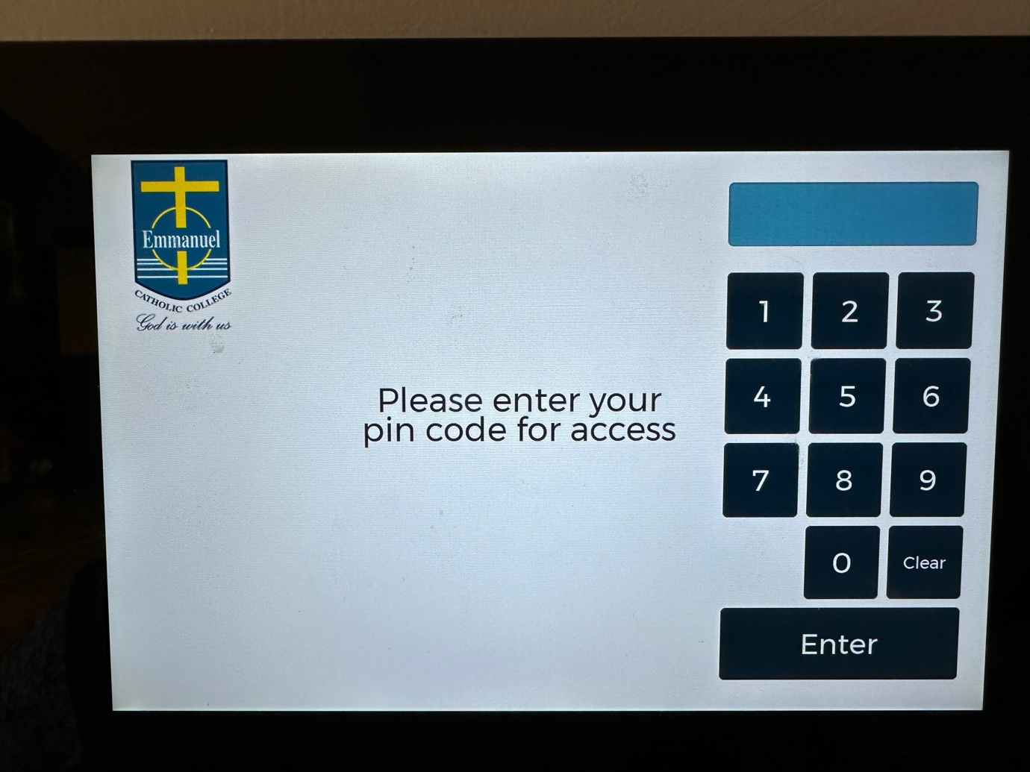

2: Navigate to Video and power on the whole system, then wait for side screens to lower and projector boxes to warm up

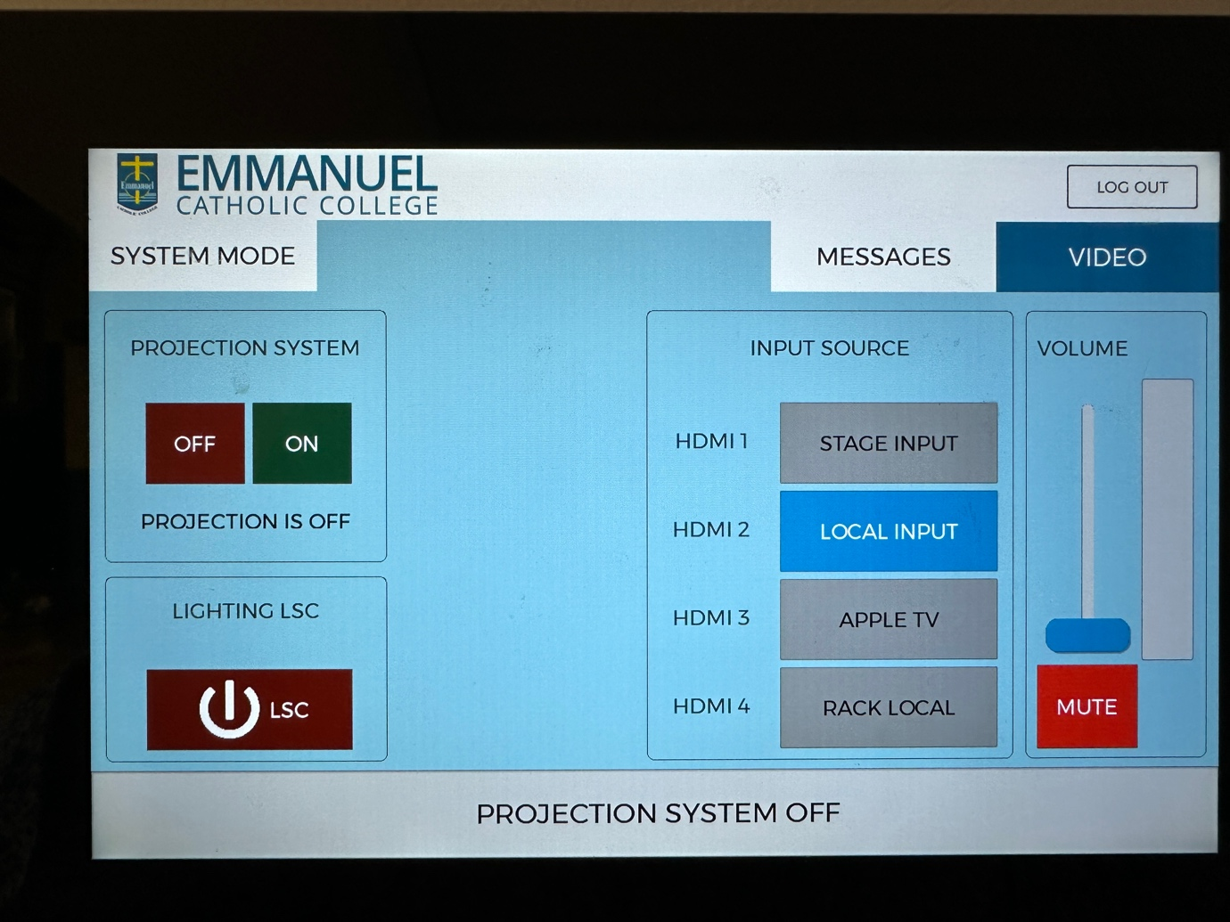

3: Change system mode to Performance mode without backstage mixer for assemblies, with backstage mixer for graduation and other performances

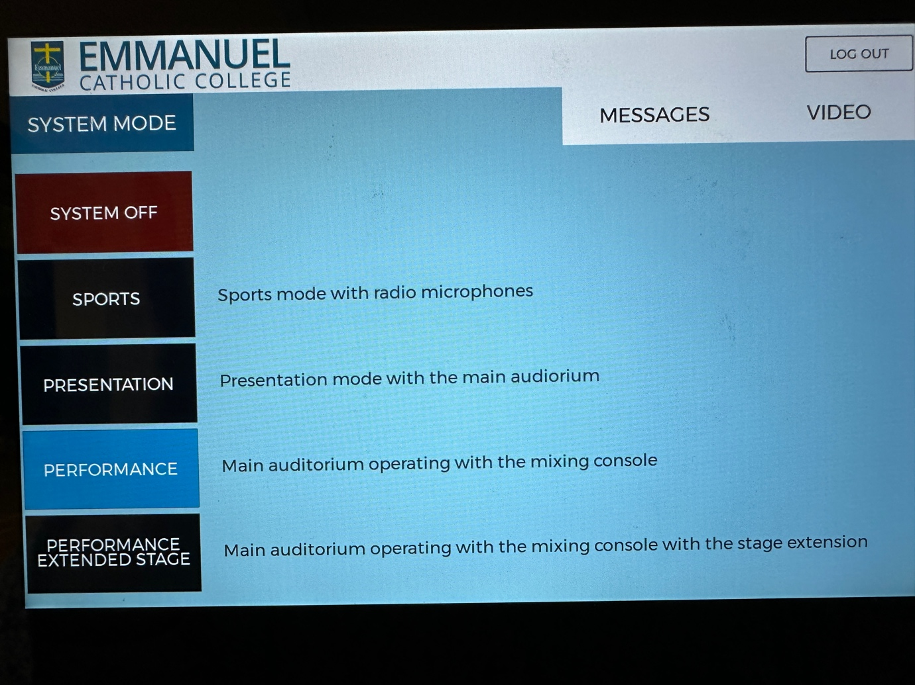

4: Connect the Presentation Laptop (Arrange with IT Department) to the screen via Type – C to HDMI cable (If mac screen adjusts size then the connection works)

5: Change Audio Output in settings from MacBook Air Speakers to “” which is the audio system

6: Connect Sound desk to system via XLR Cable to the wall plate and power on the system
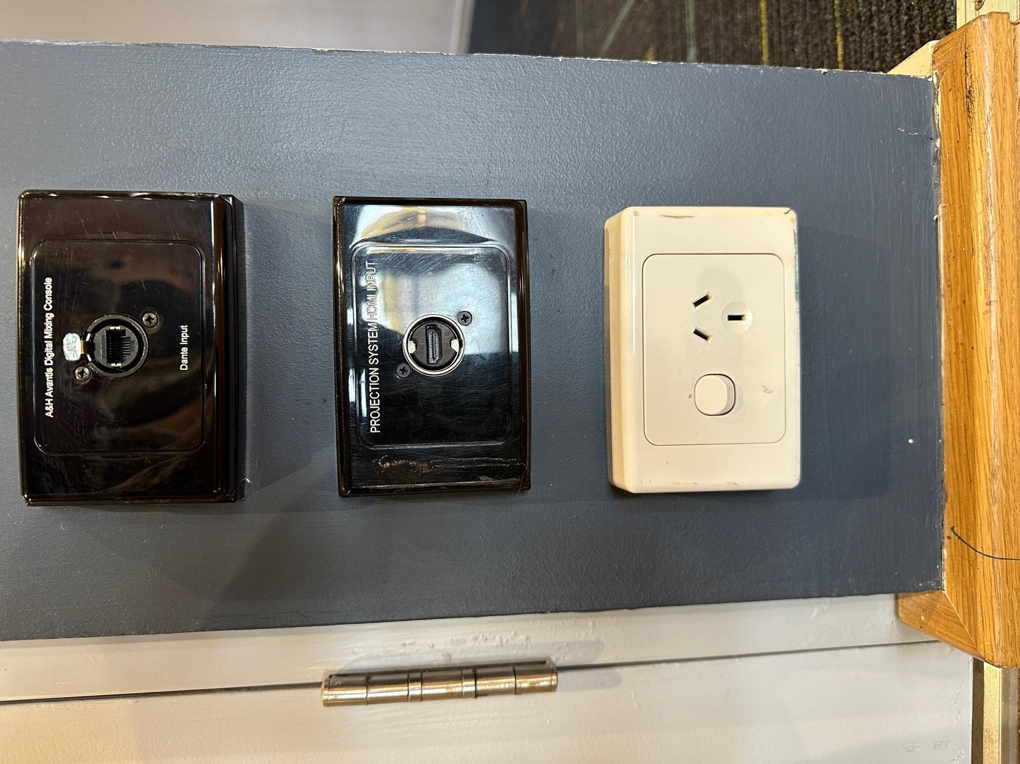

7: Setup any additional audio equipment such as instruments/microphones or the lectern and connect using appropriate wall plates/stage boxes
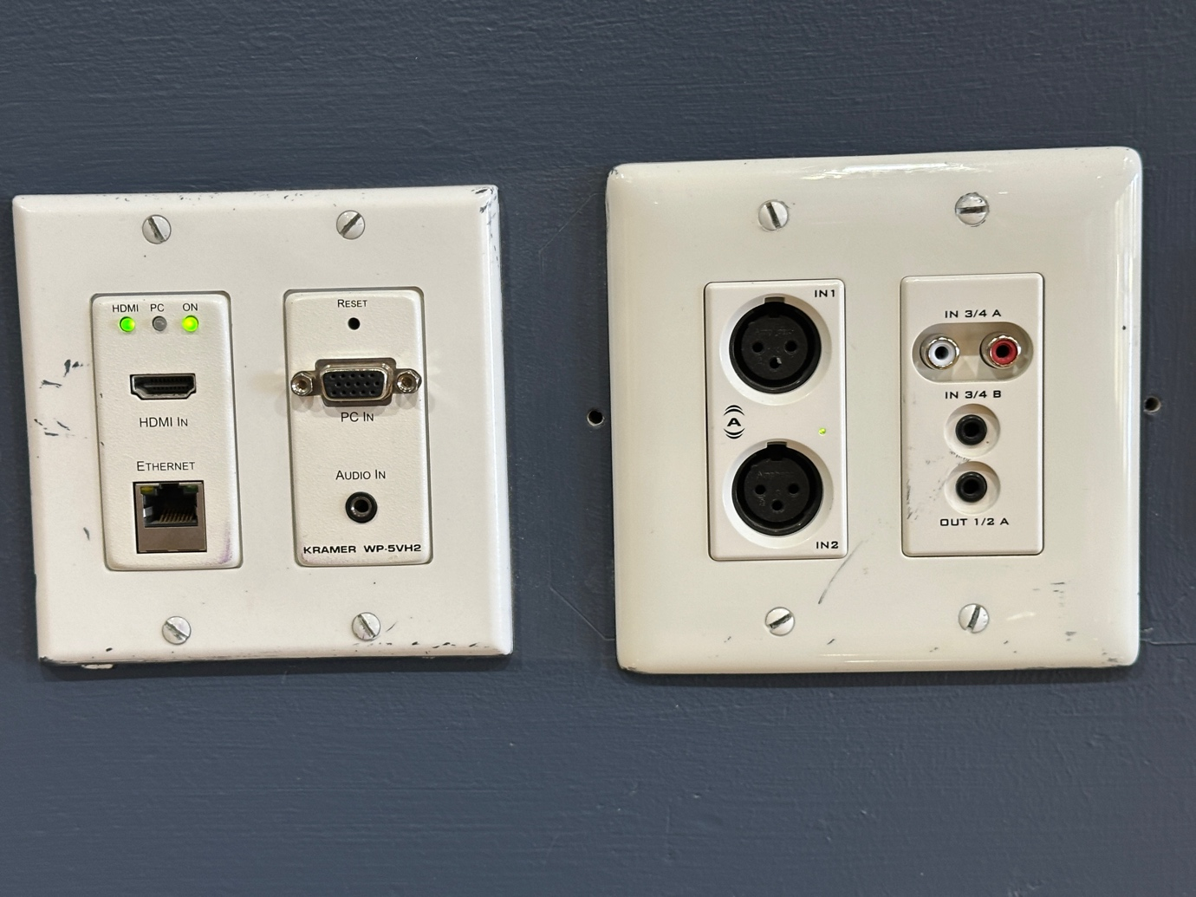

8: Run full presentation/audio test adjusting volume as you go to appropriate levels depending on presentation content

SPACE Performance Night Setup

